Milestone 4: Angular Application
Grand Canyon University: CST-391
Safa Bayraktar
11/20/2021

UI Sitemap
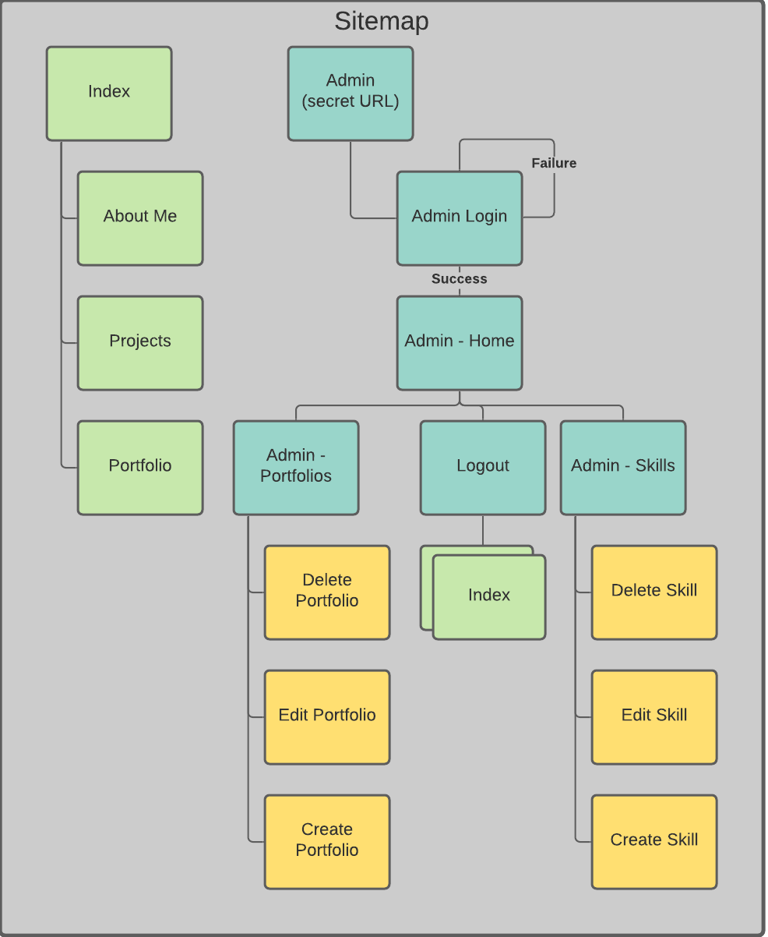

UI Wireframes
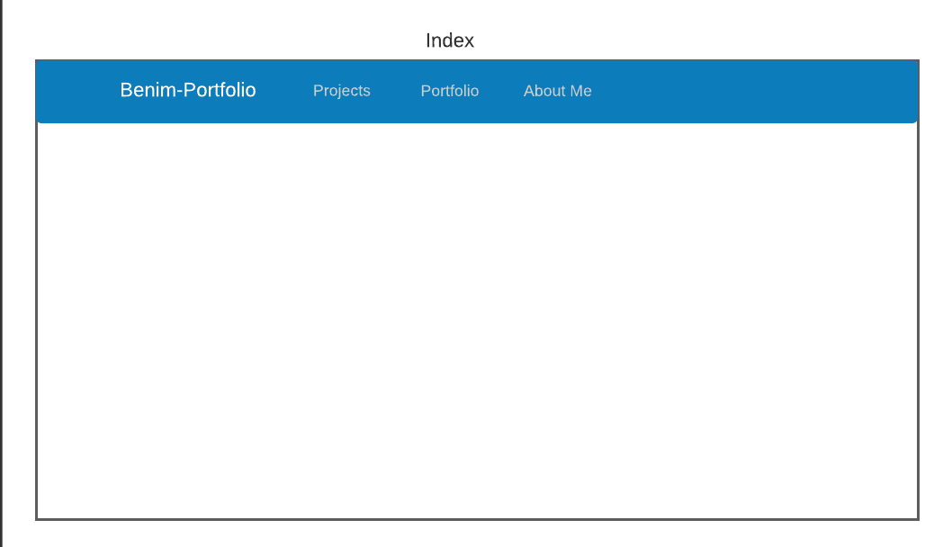
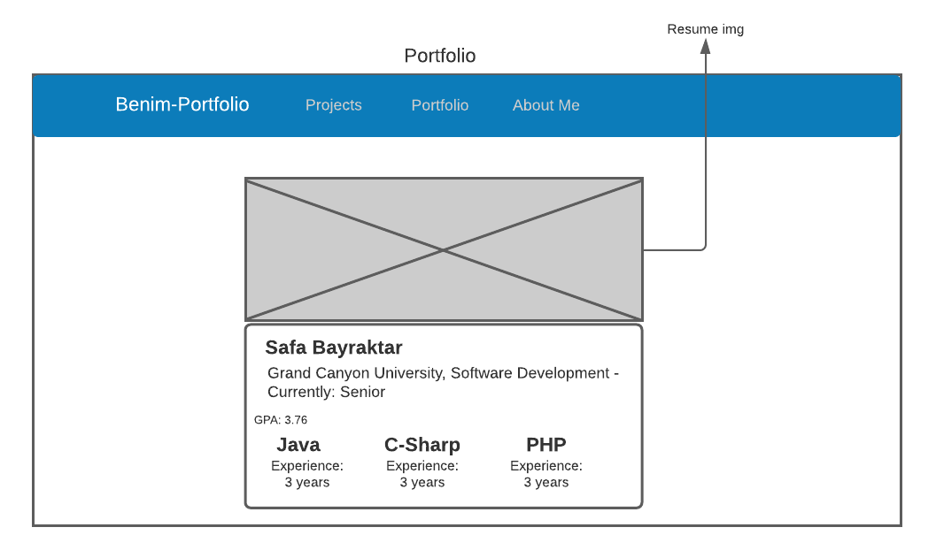
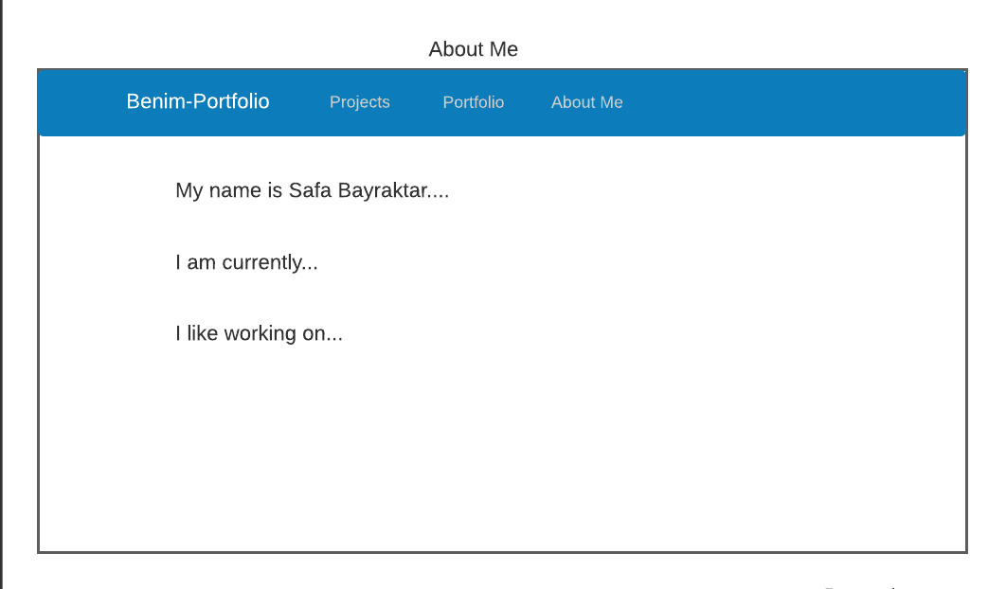
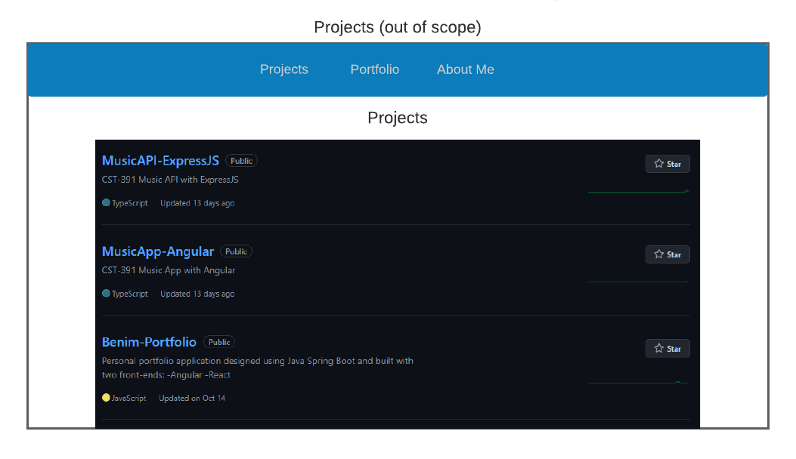
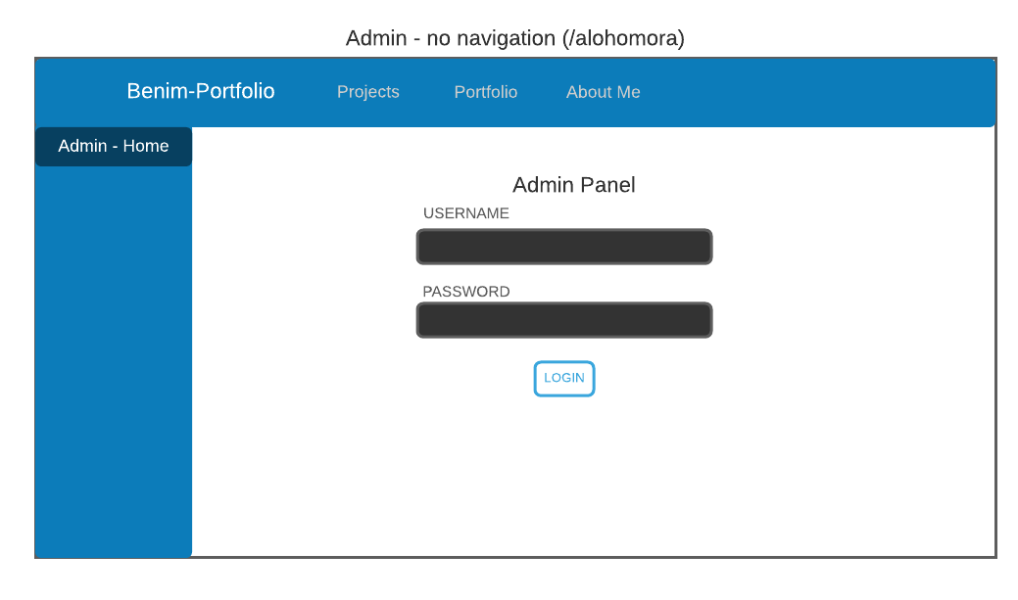
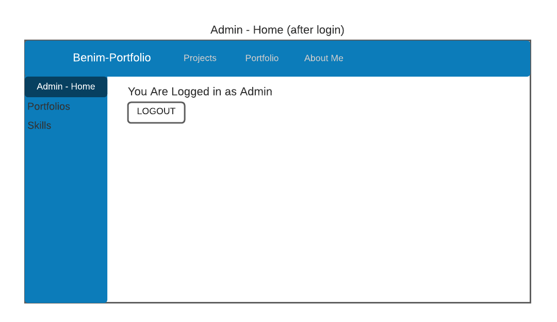
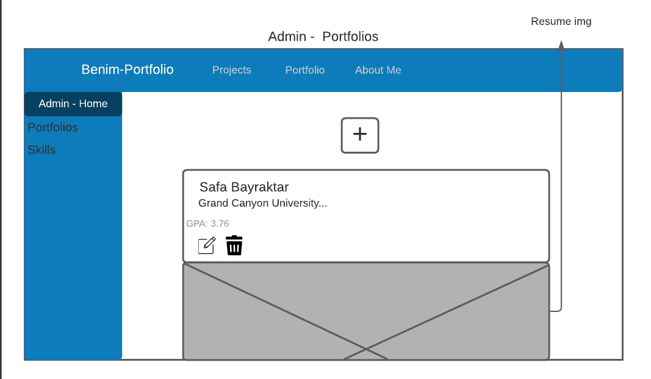
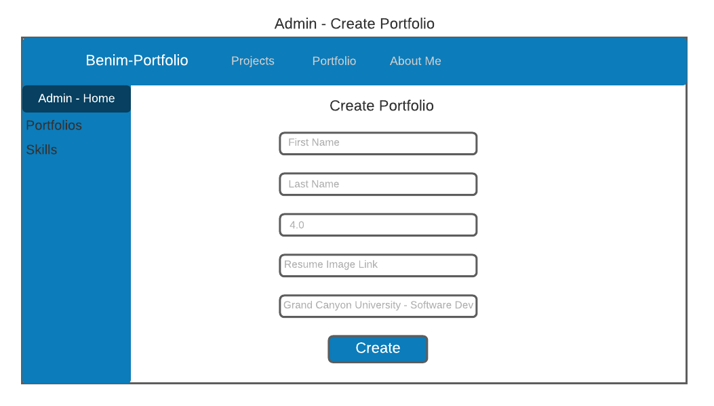
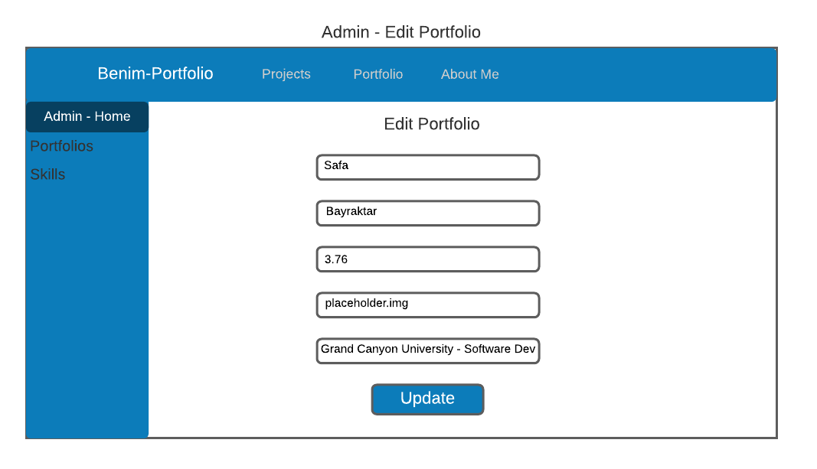
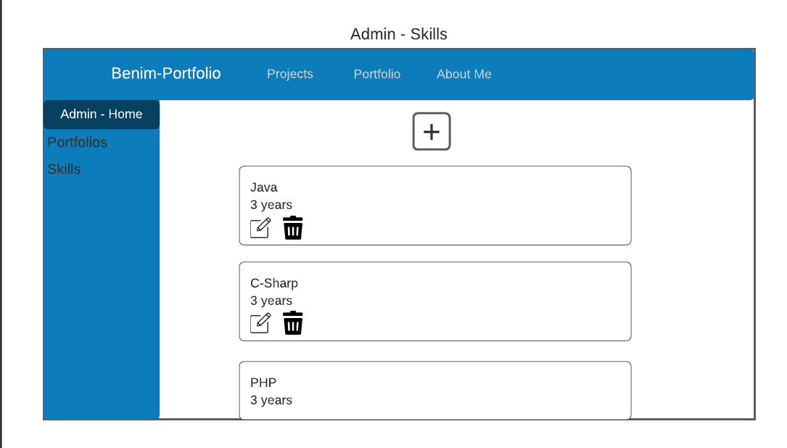
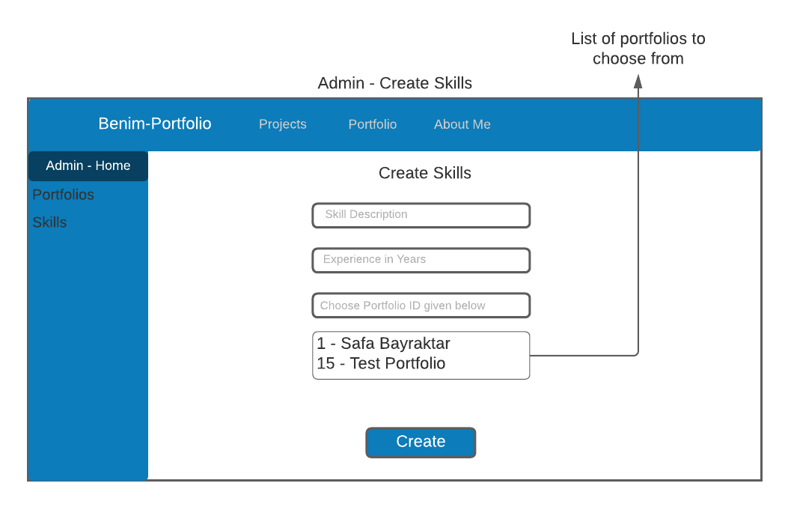
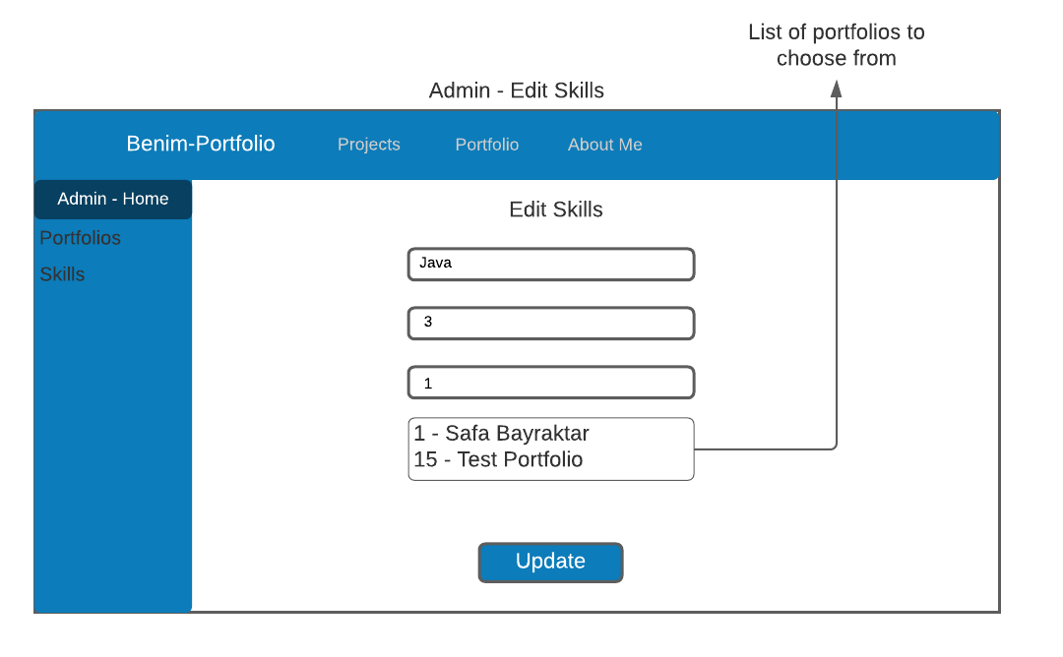

UML Class Diagrams
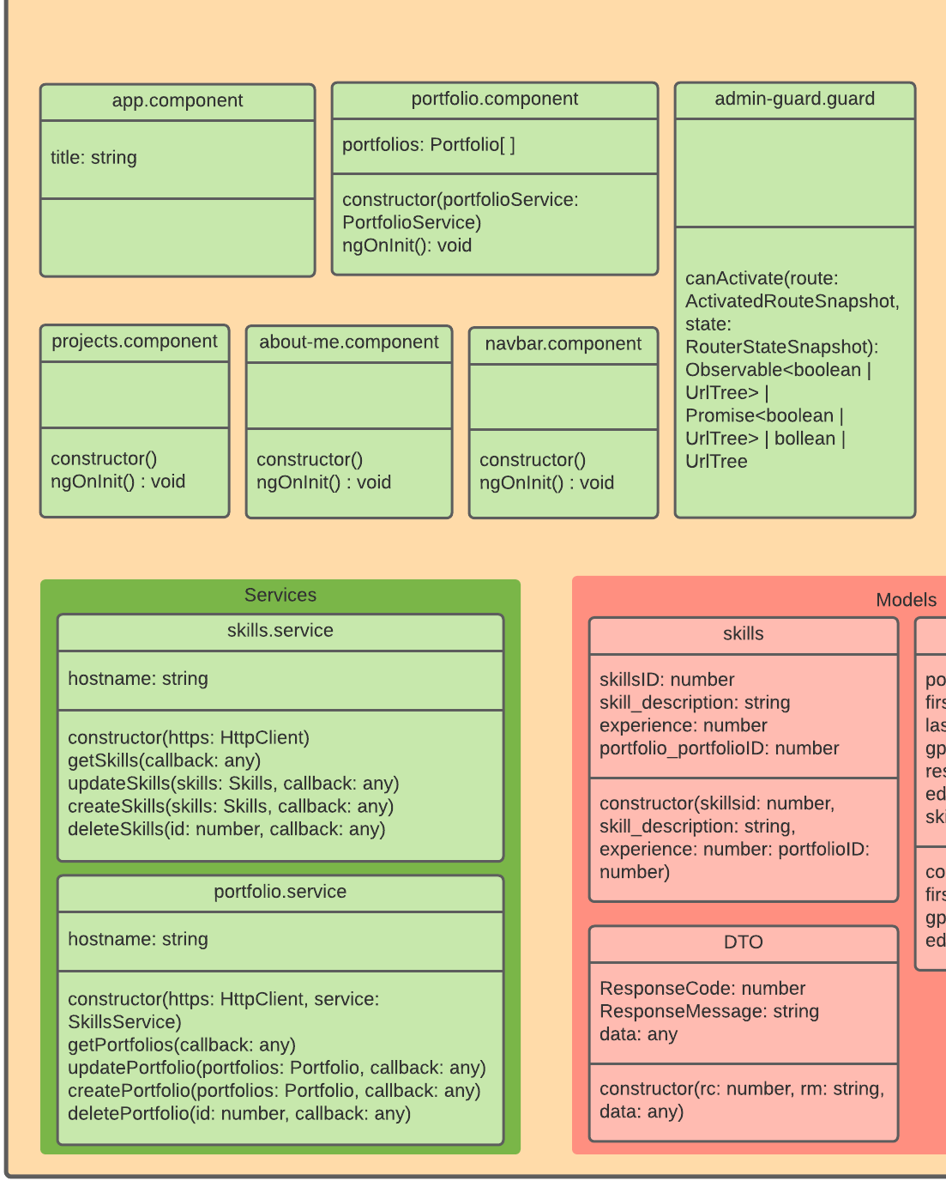
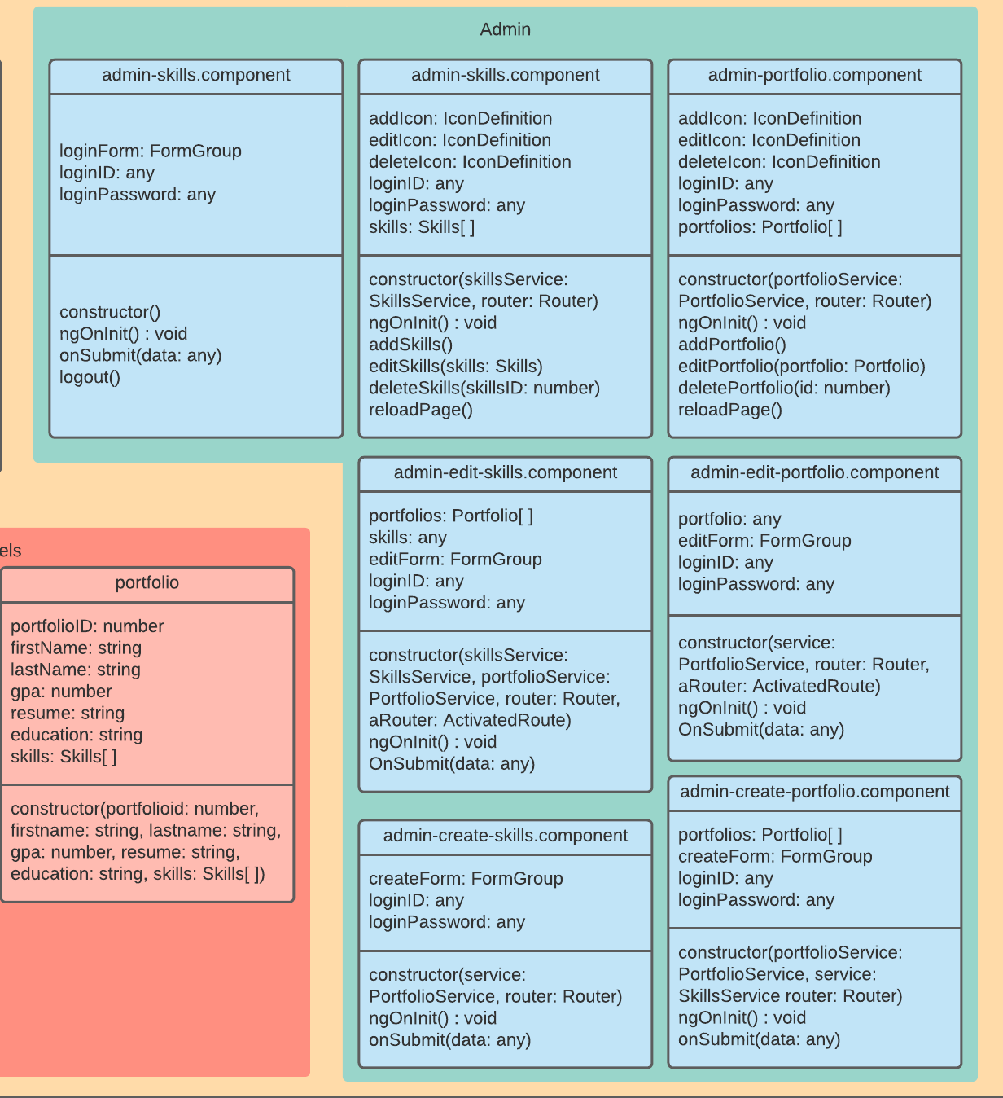

Links
- Loom
  - https://www.loom.com/share/69bc3566cab647b9bd5d8ceeb4f671b0
- Github
  - https://github.com/goktan507/Benim-Portfolio/tree/main/Milestone%204
- LucidChart – with all the diagrams above
  - https://lucid.app/lucidchart/338bbc76-2df2-464a-a556-74bb3e9939ef/edit?invitationId=inv_aa443f18-22f8-40d2-b2fa-77e2dd6797c8

